Music Player

Software Architecture Document

Version 1.1

Revision History

| **Date** | **Version** | **Description** | **Author** |
| --- | --- | --- | --- |
| 15/07/2022 | 1.0 | Initial version | Trương Samuel  Trần Hồng Minh Phúc  Trần Thiện Tiến  Phạm Ngọc Anh Thư |
| 29/07/2022 | 1.1 | Add Deployment diagram and Implementation View | Trương Samuel  Trần Thiện Tiến |

Table of Contents

1. **Introduction** **4**
   1. **Purpose** **4**
   2. **Scope** **4**
2. **Architectural Goals and Constraints** **4**
3. **Use-Case Model** **4**
4. **Logical View** **4**
   1. **Component: UI View** **6**
   2. **Component: Controllers** **8**
   3. **Component: Middleware** **9**
   4. **Component: Model** **10**
5. **Deployment** **10**
   1. **Android** **11**
   2. **Server** **11**
   3. **Database** **11**
6. **Implementation View** **11**

Software Architecture Document

# Introduction

## Purpose

This document provides a comprehensive architectural overview of the system, using a number of different architectural views to depict different aspects of the system. It is intended to capture and convey the significant architectural decisions which have been made on the system.

## Scope

This Software Architecture Document applies to the Music Player System which will be developed by Group01.

# Architectural Goals and Constraints

There are some key requirements and system constraints that have a significant bearing on the architecture. They are:

* The delay when playing music should not be greater than 3 seconds
* The security of the account should have password salting.
* The maximum users access app at the same time should be 50.
* The application design should be easy and simple to use
* Language: Javascript (React Native), Go
* Environment: Android

# Use-Case Model

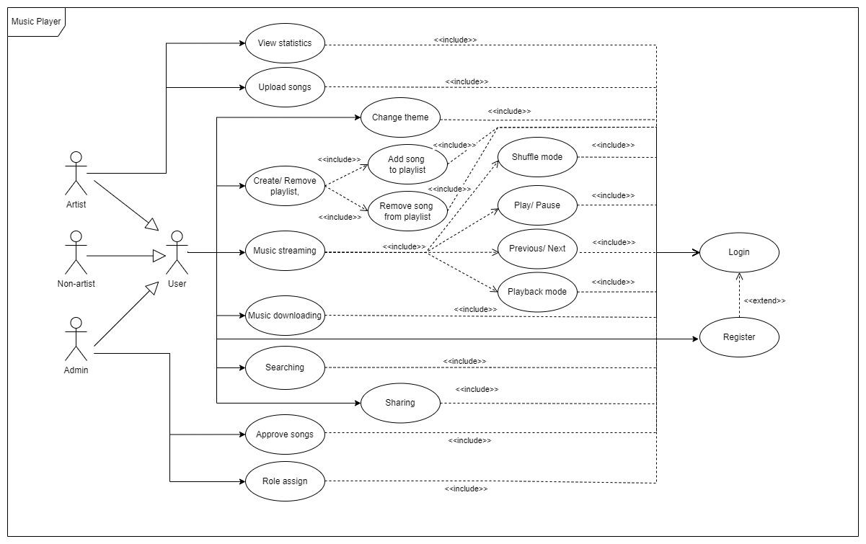

# Logical View

A description of the logical view of the architecture. Describes the most important classes, their organization in service packages and subsystems, and the organization of these subsystems into layers. Also describes the most important use-case realizations, for example, the dynamic aspects of the architecture. Class diagrams may be included to illustrate the relationships between architecturally significant classes, subsystems, packages and layers.

The logical view of the Music Player is implemented same as MVC and comprised of 4 main components:

* **UI View:**
  + Responsibilities: Contains classes for each of the forms that the actors use to communicate with the system.
  + Service(s): Send HTTP Request to **Controllers** component when actors interact with UI.
* **Controllers:**
  + Responsibilities: handle application logic and request mapping.
  + Service(s): Handles HTTP Requests from User (**View** component) and forward to **Middleware** component for authentication. If the authentication is successful, continue to the **Model** component to request data through the built-in APIs (Core API) or external APIs. Otherwise, **Controllers** send an error response to the **View** component for display to the user and disallow access to the **Model** component
* **Middleware**
  + Responsibilities: Authenticate user and decide whether the user can access to the **Model** or not
  + Service(s): Receive HTTP Request from **Controller** and check if user is authenticated. If successful, **middleware** will give user access token to access **model.**
* **Model**
  + Responsibilities: Contains classes that represent all the data and data manipulation stored in MySQL database.
  + Service(s): Working with database through CRUD operations (create, read, update, delete)

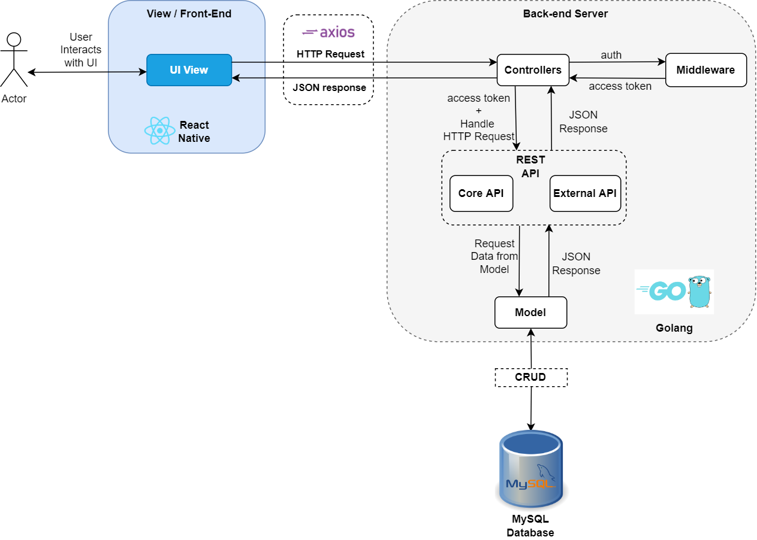

## Component: UI View

* Explain for all classes: Each class will represent buttons or text fields that users can interact.

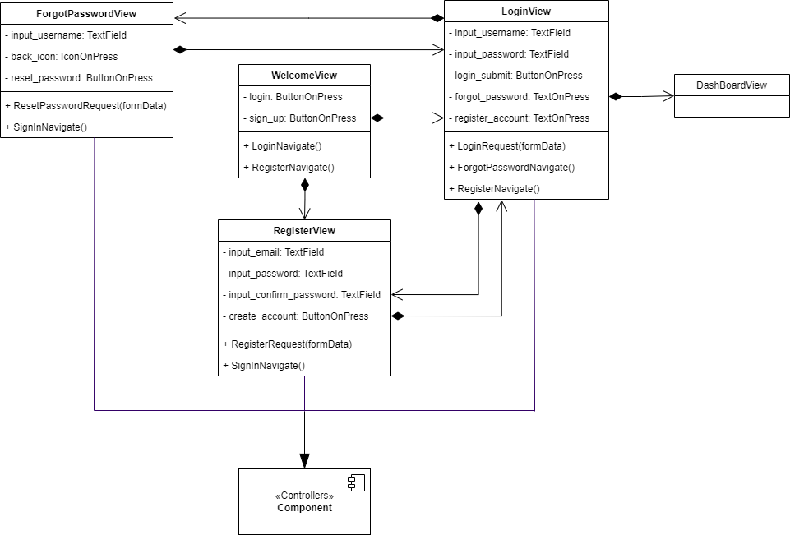

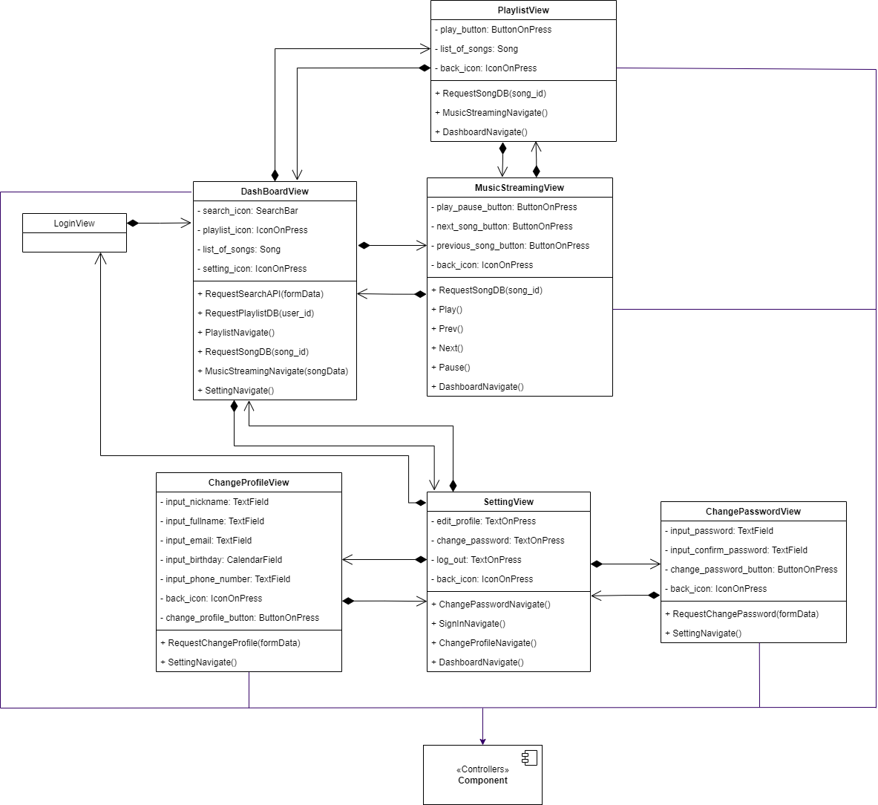

## Component: Controllers

* userControllers: Handle user-related interactions on the system (such as login, register, change password,...)
* songControllers: Handle user and song related interactions (stream music, create playlist, add song to playlist,...)

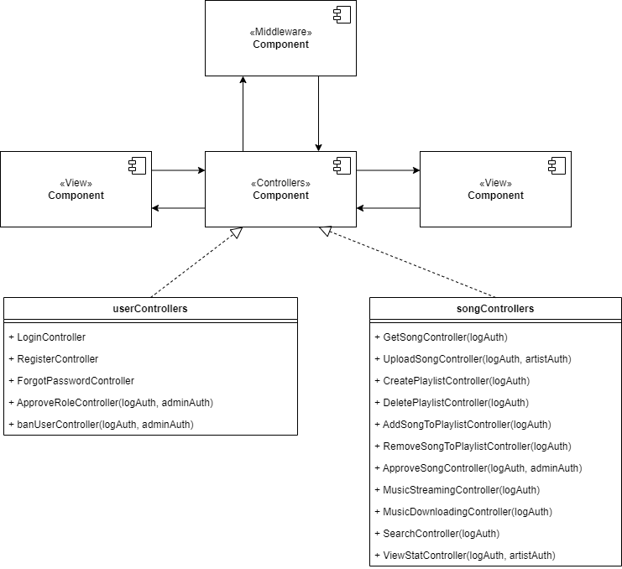

## Component: Middleware

* AuthMiddleware: Handle user authentication (for example: check if the user is logged in before or if the user is admin/artist,...)
* ErrorMiddleware: Handle common errors and notify users of solutions (such as enter the wrong password, enter the wrong password more than 3 times, the user requested the wrong format,...)

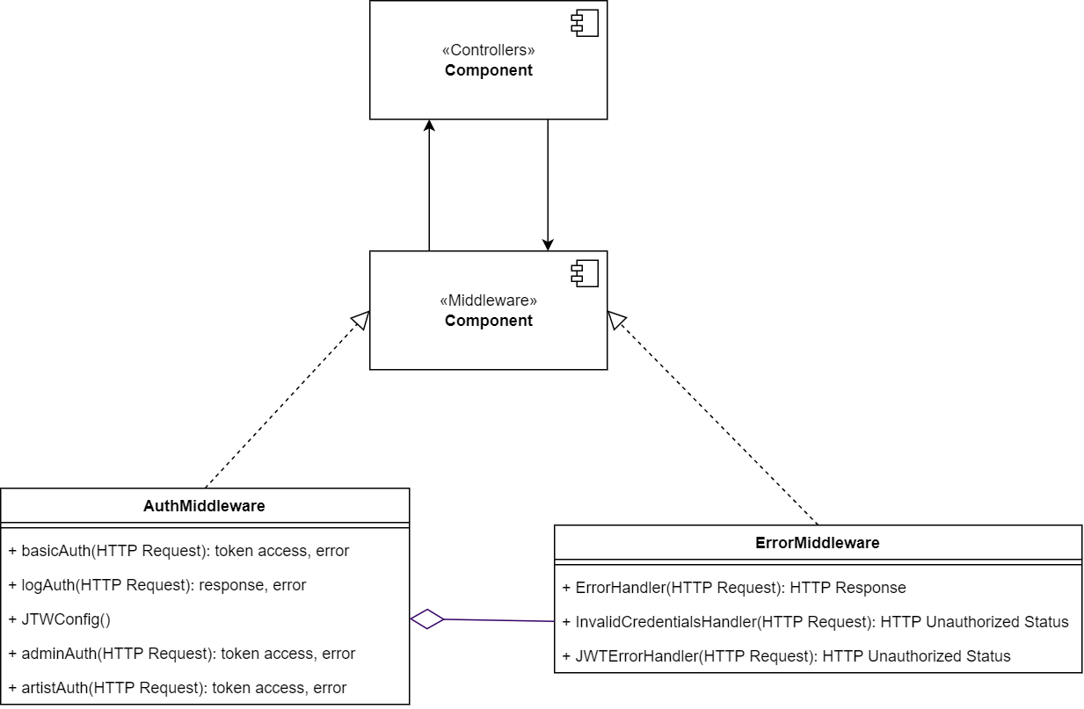

## Component: Model

* UserModel: data and data interactions on the database related to User (login - read, register - create, change password - update,...)
* SongModel: data and data interactions on the database related to Song (play music - read, delete song from playlist - delete, update name/title of song - update,...)
* PlaylistModel: data and data interactions on the database related to Playlist (create playlist - create, choose any playlist - read,...)

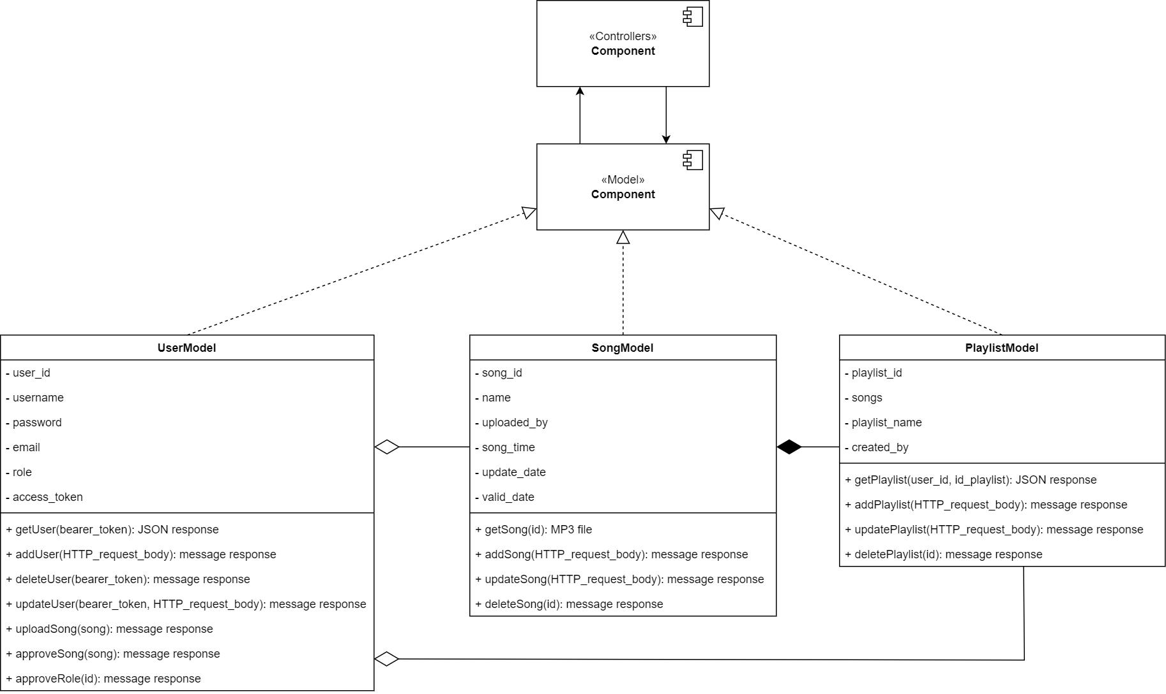

# Deployment

This section describes one or more physical network (hardware) configurations on which the software is deployed and run. At a minimum for each configuration it should indicate the physical nodes (computers, CPUs) that execute the software, and their interconnections (bus, LAN, point-to-point, and so on.) Also include a mapping of the processes of the Process View onto the physical nodes.

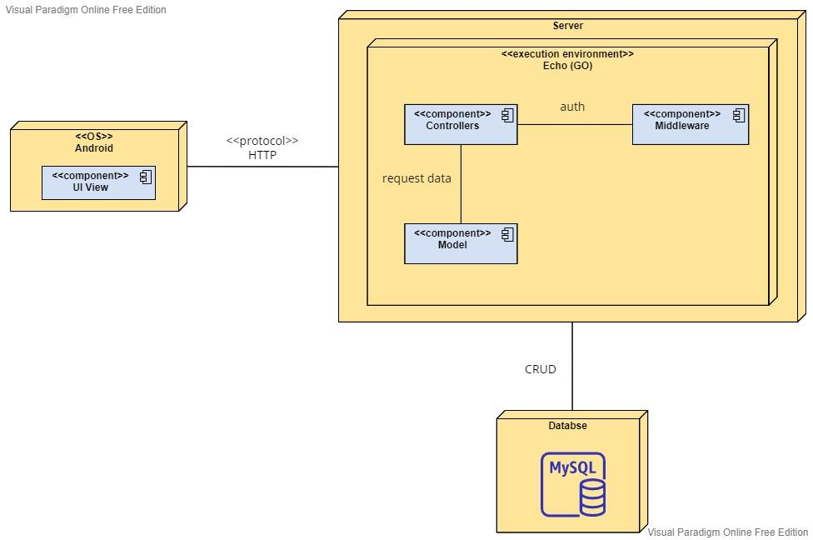

## Android

Users use the Music Player app using Android phones which are connected to Server via Internet.

## Server

The main server handles data-processing for the Music Player app.

## Database

All data is stored here. Server interacts with MySQL database through CRUD operation

# Implementation View

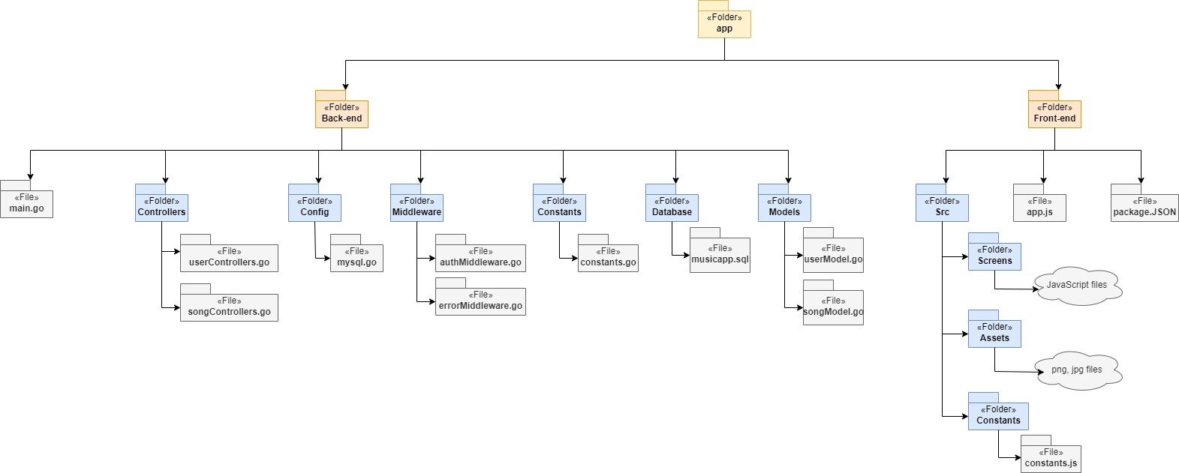

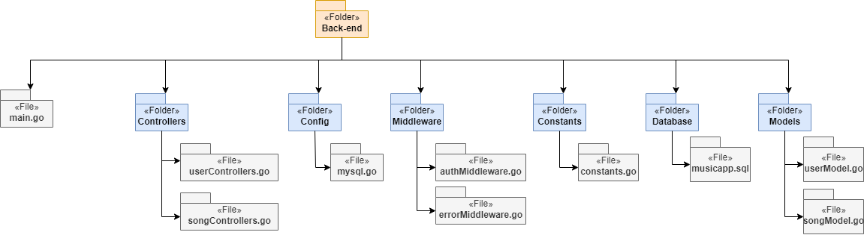

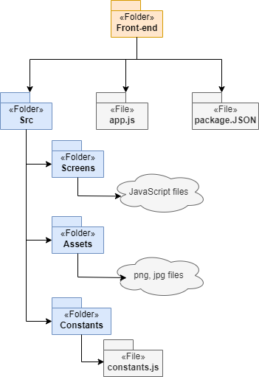

* **Note:**
  + In folder ***Front-end/Src/Screens****,* itcontains all our application screens/feature used by React Native framework.
  + In folder ***Front-end/Src/Assets***, itcontains all images with jpg, png file used for background, icon, etc.